Feel at home in your welcoming holiday retreat!
To ensure a comfortable and safe stay for everyone,
please follow these house rules during your stay

Adress
Marina Real III
- Street: Carrer d’Electra or Carrer Castor in Denia. Opposite of the Supermercado Masymas.
- Portal 6, Floor 4, apartment D.
- You can take lift or stairs.

General
- No smoking or vaping in the house.
- No drugs in or around the house.
- No parties or events.
- Silence in the compound between 22:00 and 09:00 hrs. You’ll risk a fine from the compound administrator if you do not follow the rules, so be aware of your behavior please!

WiFi
- Name: Movistar-wifi6-4800, security code: V9Y3CywAE4VXAFHw373F.

Key and asses
- There is an access key, front door key and a blue garage door switch.
In case of loss it costs €80 per key. When we have to call a locksmith it’s €200.
- With the access key you can take any door to enter the compound.
- When leaving take all the keys with you because, when the door closes you cannot go back in without key.
- Do not bring other people into the house/compound you don’t know.

Parking
- You can park your car in the garage under the building. We have our own space; number 139. Only park there, you’ll risk a fine if you park elsewhere. Outside the building, around the compound, you can park for free – don’t leave anything in the car, to prevent theft.
- You can take the lift to access the building from the garage.

Front door
- Locked when leaving during the day.
- Deadbolt at night for extra safety.
- Close doors and windows when leaving. Don’t let anyone else inside you don’t know.

Swimming pool compound
- Swimming pool is lifeguarded from 11.00-15.00 and 17.00-21.00, from 23 June till 7 September. Before or after those hours it’s prohibited to use the pool, you’ll risk a fine from the compound administrator when using it!
- Eating and drinking is not allowed within the pool enclosures. Glass is strictly prohibited. You’ll risk a fine from the administrator if you do!

Kitchen
- Items in the kitchen incl. fridge for use
- Oven is also a microwave.
- Dishwasher, select the program you want, push the “play button” on the right side and close it.
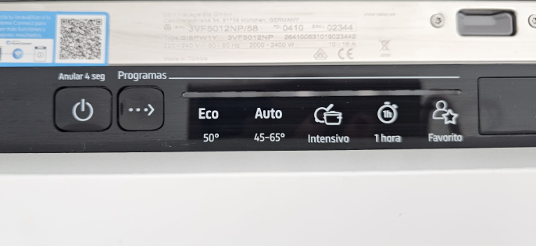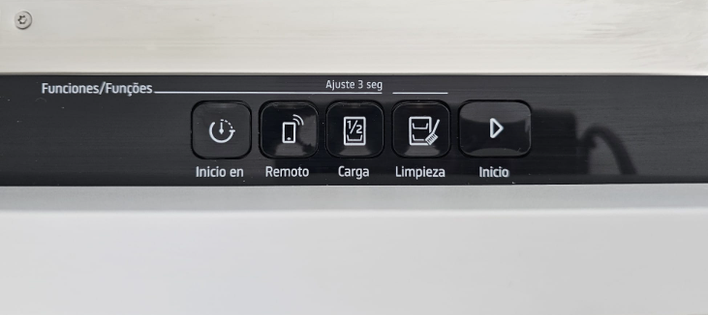
- Washing machine, contact us for using.

TV living room
- To turn on and off the TV, use the black remote control
- Press the home button and make a selection for an app
- Netflix, Youtube, Videoland and TV channels available for use – please do not download or buy extra options without consulting us. You can use the guest account.

Air conditioning
- Put the symbol of the leave on off. Temperature at around 22 °c select in the 3 zones. Living, and 2 bedrooms.
- Close doors and windows when using airco. Otherwise it’s not working.
- When the airco makes noises; turn it off, wait 10 sec and put it back on. You can also switch off the fuse in the fuse box (‘airconditioning’) in the hallway.

Roof Terrace
- After using please cover the cushions, always (because of bird poop).
- Carefully open and close the parasol. Don’t open with hard wind. After using close it, wrap it and lay it on the ground.
- Use the plastic cups for outside drinking.
- Please be quiet after 22.00. hrs.

Jacuzzi
- Can be used between 08.00-22.00 hrs. Otherwise it makes too much noise for neighbors.
- Be careful with the hood without scratching the walls. Put it on the ground before entering the tub.
- Sometimes the power shuts off. Flip the switch in the fuse box “Jacuzzi” in the hallway back on.

Bathroom
- Make sure the water does not overflow the sink on the floor in the shower; please close the shower curtain well!
- The fans in both bathrooms operate by one switch in the second bathroom.
- Please clean the glass with the wiper to prevent limescale.

Garbage
- Please separate glass and paper from the garbage.
- Garbage bag (incl. plastic) can be thrown away in the big bins outside the building. Please make sure no garbage is left after leaving the apartment.

Check-out before 12.00 or in consultation
When leaving put the keys on the kitchen counter and close the door behind you.
When you travel by car. Put your car first outside the garage and go back upstairs to leave the blue switch on the counter.

Questions?
- Please do not hesitate to text or call us in case of any questions or hesitation on how things work.
We are happy to help, anytime!
Nick: +31(0)6 27 65 29 59
Martine: +31(0)6 30 02 97 01

We wish you a very pleasant stay in Dénia!

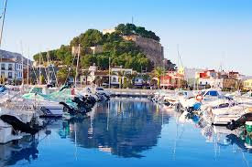

Dénia - een unieke badplaats in Spanje
https://www.ontdek-denia.nl/

Vakantie in Dénia – kleine authentieke stad aan Costa Blanca in Spanje
https://www.spanjevoorjou.com/vakantie-in-denia.html

Denia | Stranden, activiteiten, restaurants, hotels en bereikbaarheid
https://www.verrassendvalencia.nl/denia.html

Drugstore/chemist store
- Farmacia Ecoceutics Montgó, Carrer de la Corona Boreal 11
Next to Masymas
Monday 09:00 – 21:30
Tuesday 09:00 – 21:30
Wednesday 09:00 – 21:30
Thursday 09:00 – 21:30
Friday 09:00 – 21:30
Saturday 09:00 – 21:30
Sunday 12:00 – 15:00

Supermarkets
- Masymas, Carrer de la Corona Boreal 11
Monday 09:00 – 22:00
Tuesday 09:00 – 22:00
Wednesday 09:00 – 22:00
Thursday 09:00 – 22:00
Friday 09:00 – 22:00
Saturday 09:00 – 22:00
Sunday 09:00 – 21:30
- Consum, Cami de les Alqueries 3
Monday 09:00 – 21:30
Tuesday 09:00 – 21:30
Wednesday 09:00 – 21:30
Thursday 09:00 – 21:30
Friday 09:00 – 21:30
Saturday 09:00 – 21:30
Sunday 09:00 – 14:30
- LIDL, Cami de Sant Joan
Monday 09:00 – 22:00
Tuesday 09:00 – 22:00
Wednesday 09:00 – 22:00
Thursday 09:00 – 22:00
Friday 09:00 – 22:00
Saturday 09:00 – 22:00
Sunday 09:00 – 22:00

Harber ferry to Ibiza, Mallorca
https://www.balearia.com
https://www.denia.com/el-puerto/

Bus\tram connection
- FGV-TRAM d’Alacant offices are in Avda. Villajoyosa, 2. 03016 Alicante.
https://www.tramalacant.es/?idioma=_es

- Busstation Denia
https://www.denia.com/nl/estacion-de-autobuses/
https://www.alsa.com/en/coach/denia-alicante
https://www.omio.nl/bussen/denia-i0s4a

Beaches
- Playa de Marineta Casiana
- Playa Escollera Norte en Denia
- Playa de Les Marines

A lot of good restaurants in Denia

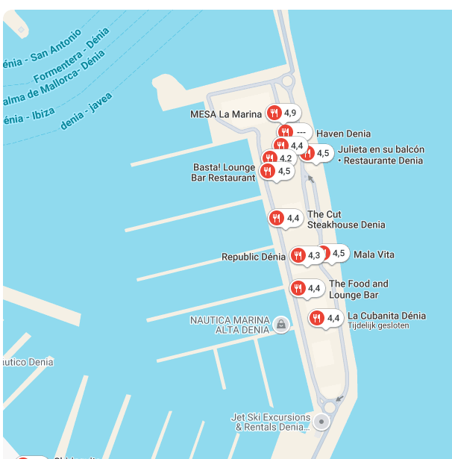

Black Market BBQ, Denia
Mala Vita
Julieta
Basta Lounge – live music on Sundays
Cha Cha Bistro Bar
Bar Gaudi Taverna

In case of emergencies

Emergency Procedures for the Apartment
- Fire Safety: fire extinguishers are located in the hallway outside the door and in the kitchen
- Smoke detectors and fire alarms are installed

Emergency Contact Numbers
- Local emergency Services call 112
- Policía Nacional
Carrer Castell d'Olimbroi, 5 · +34 965 78 38 51

Local Hospitals/Medical Facilities
- Hospital HCB Denia
Av. de Gandia, 45 · +34 966 13 01 90

